Lipid accumulation in NAFLD and DIFLD models

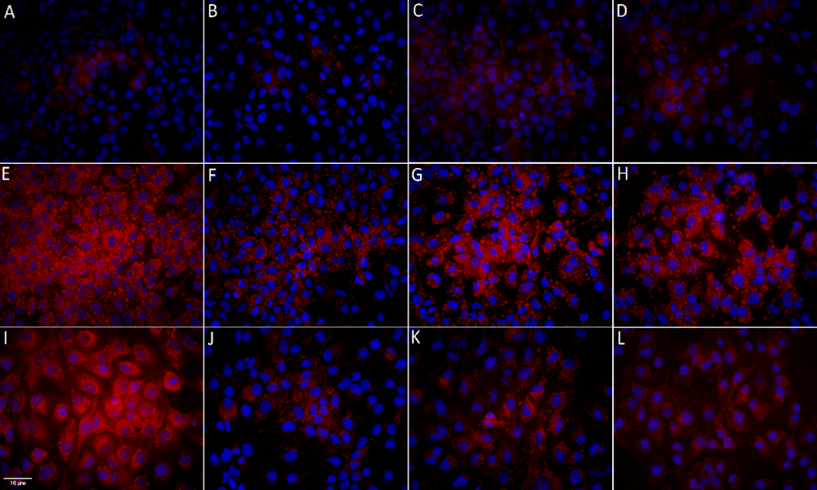

Visualization of the lipid accumulation with Oil-Red O-dye.
Lipid accumulation in Huh7 cells was visualized with Oil-Red-O dye, while DAPI (blue color) was used to stain nuclei. A- DMEM (negative control), B- 5nM LIRA, C- 10nM LIRA, D- 20nM LIRA, E- 0.5 mM OA (positive control), F- 0.5mM oleic acid and 5nM LIRA, G- 0.5mM oleic acid and 10nM LIRA, H- 0.5mM oleic acid and 20nM LIRA, I- 20µM amiodarone, J- 20µM amiodarone and 5nM LIRA, 20µM amiodarone and 10nM LIRA K- 20µM amiodarone and 20nM LIRA. Size bar represents 10µm. Dulbecco’s modified eagle medium (DMEM), liraglutide (LIRA/nM), oleic acid (OA/mM), amiodarone (AMD/µM)

